***Abstract –* This document details the processes involved to build a signal processing circuit for EMG (Electromyogram) circuits. These circuits were used to control the movements of a Pacman video game on the google webpage. The board named “ESET 359 Board” was provided to students and used throughout this entire process.**

1. Introduction

This project incorporated each of the concepts and skills developed during ESET 359 Electronic Instrumentation course. To complete this project, two instrumentation amplifiers input to band pass filters were implemented on the board. The combination of these two amplifiers were used to process the electrical signals from muscles in the biceps of individuals. Throughout the remainder of this report, any mention of a feature for one EMG was implemented to both EMGs on the board. The bicep muscle contractions were used to control the movement of the Pacman character on the videogame screen.

1. Results

The signal from the muscles is an analog signal with noise before it is filter through both hardware and software on LabVIEW. The first filter comes in the form of a hardware bandpass filter on the board. After reading this value on the board, the two signals are merged. The raw ADC readings are then converted to be read as a range of values from zero to five with a 10-bit resolution. The two signals are also sent through a Butterworth lowpass filter for further limitation of signal noise.

The two signals having a range of zero to five made them easier to work with; however, the two signals needed to read as either a 0 or a 1 for Boolean logic to take place.

To start this processing technique, the baseline value for the signal when the muscle was relaxed was obtained. In the case of this project, the value for a muscle contraction was set to 0.06. This was a low enough number that a large muscle contraction wasn’t required to dictate the direction of Pacman’s travel. There was still some minor noise seen in this configuration still had a marginal number of false positives, but it kept the effort required to activate a high signal for the control.

The control logic for the movement of Pacman was as follows in Table 1, the truth Table. This control logic works for controlling Pacman; however, it’s difficult to time the contractions in the right place to move Pacman around the screen accurately. With enough practice the user could score some serious points, but with the limited practice time before demonstrating to a grader, Pacman doesn’t do a world record run.

TABLE 1

Final Control Logic for Pacman

|  |  |  |
| --- | --- | --- |
| **Left Arm** | **Right Arm** | **Output** |
| 0 | 0 | Down |
| 0 | 1 | Right |
| 1 | 0 | Left |
| 1 | 1 | Up |

The original control logic was not as outline in Table 1. In looking back on the original logic, it was wishful thinking at best. The game didn’t behave properly when two different control signals were input at the same time. With the following “incomplete” logic table, Pacman would hit the first corner he went to and just stayed there. He wouldn’t move anywhere outside of that, and the ghosts wouldn’t chase him after the first of his lives was lost; they merely moved around in a circle. The final position of Pacman after the initial improper control logic is shown in Figure 3 of this report.

TABLE 2

Original Control Logic for Pacman

|  |  |  |  |
| --- | --- | --- | --- |
| **Left Arm** | **Output** | **Right Arm** | **Output** |
| 0 | Down | 0 | Left |
| 1 | Up | 1 | Right |

To control keyboard input, the values of the keyboard buttons were needed to be sent to the keyboard using the provided SubVI from the TA. For the 4 buttons needed, the values are outlined in Table 3.

TABLE 3

Numbers Loaded to SubVI

|  |  |
| --- | --- |
| **Button Pressed** | **Number** |
| Left | 37 |
| Up | 38 |
| Right | 39 |
| Down | 40 |

Additionally, the filtered data acquired from contracting the right and left arm is shown in Figures 4 and 5. When comparing the data captured in those Figures with the logic table in Table 1, the data captured in Figure 6 checks out. The system behaves as desired with this configuration.

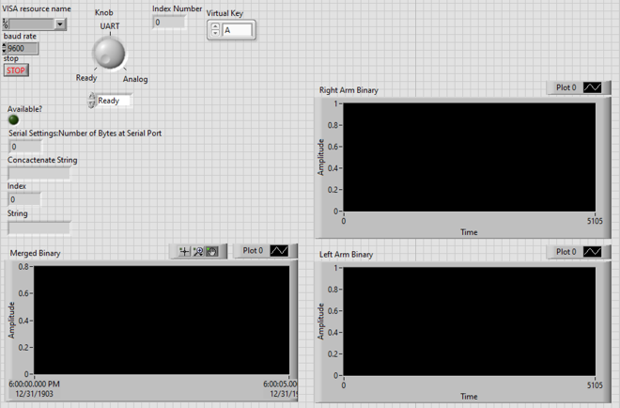

Figure : Project Front Panel

Figure : Project Block Diagram

Figure : Stationary Pacman from Improper Control Logic

Figure : Right Arm Readings

Figure : Left Arm Readings

Figure : Button to Be Pressed

1. Conclusion

This project allowed students to understand how to capture EMG signals and apply them as inputs for other purposes.

The activity in this project was a task applicable to a task student’s professional practice would require. This Pacman activity worked as a fun task to complete as practice for complex problem solving.

Acknowledgement

This semester wouldn’t have been possible without the generous help of both professors and lab instructors.

To Devon: you’ve been a great TA and very helpful throughout this semester with every question in every lab.

To Dr. Kim: your in-depth teaching has helped student to have a grasp of material. Thank you for the support

References

[1] Mayo Clinic Staff. “Electromyography (EMG),” *mayocclinic.org*, May. 21, 2019. [Online]. Available: <https://www.mayoclinic.org/tests-procedures/emg/about/pac-20393913>. [Accessed Dec. 4, 2021].

[2] “Electromyography (EMG),” *hopkinsmedicine.org*. [Online]. Available: <https://www.hopkinsmedicine.org/health/treatment-tests-and-therapies/electromyography-emg>. [Accessed Dec. 3, 2021].

[3] M. Freedman. “EMG Electromyography),” *healthgrades.com*. Nov. 24, 2020. [Online]. Available: <https://www.healthgrades.com/right-care/electromyogram-emg/>. [Accessed Dec. 4, 2021].

[4] “Electromyography (EMG) and Nerve Conduction Studies,” *medcineplus.gov*. Nov. 15, 2021. [Online]. Available: <https://medlineplus.gov/lab-tests/electromyography-emg-and-nerve-conduction-studies/>. [Accessed Dec. 2, 2021].